|  |
| --- |
|  |

**Non-Governmental Organizations in Pune City, State of Maharashtra, India**

**Mohammad** **Amiri** [mohammad.amiri.qiau@gmail.com](mailto:mohammad.amiri.qiau@gmail.com)

**Authors:** Prof. Siddaiah.S.V.

**Abstarct:**

Role of Non-government Organizations (NGOs) in the development process in the third world countries like India is very crucial, especially in the 21st Century. They have a greater role to play in the lives and livelihoods of the tribal and backward communities of India today. An attempt has been made in this paper to see the role of an NGO in the development of settlement. It is also attempted to understand how the information and support from the agency (NGO) helped the community to become . The present paper is an outcome of fieldwork among settlement in the Gangajal Tanda as part of PhD work. An NGO by name NEEDS is working for the development of dominant tribe (economically, socially, politically and numerically in in Gangajal Tanda settlement Of Haveri r District in Karnataka The drawbacks of the developmental

**Key Words:**

Key Words: : Women empowerment, child right, human rights, labour rights, education, health, agriculture, animal welfare etc

**Introduction:**

In a democratic system, the role of the state is primary and most crucial in formulating and implementing the social and economic development programmes. However, in the contemporary society, the problems that people have been facing especially the poor are much more

complex. This is especially true in a country like India where a large number of vulnerable sections are experiencing inequalities at all the levels.

**Development Ngo And** Development Process, Ngo India Development Development does not only mean economic development but also includes promoting social equality, gender equality, improving quality of life etc., It is not possible for government alone to effectively undertaking such complex development activities. So, there is essentiality of other groups or organizations to support the government on various fronts. This essentiality paved way for the emergence of civil society.Non-Governmnt organizations (NGOs) being a major arm of civil society thus have a crucial role in the country’s development process.

**NGOs IN INDIA:**

Social service is associated with India since ancient times. It is said that even Mahatma Gandhi after attaining independence wanted Indian National congress to be transformed into a Public service organization. Although such proposal was rejected, later many of staunch Gandhi followers did setup large number of voluntary orgs across various parts of the country to carry of the constructive works on Gandhian principles. However, the real and identified registration and formation of NGOs emerged in India from early 1970s. Immediately after their formal inception, NGOS received grater thrust form the Government in more than one ways. The GOI during the sixth Five year plan with its famous”GARIBI HATAO” slogan did recognize the importance of NGOs in the development process of India. In the seventh FYP, it gave a task of developing “self-reliance communities” to NGOs for promoting rural development. Later in the eighth FYP, government sought to promote nationwide network of NGOs. In its ninth FYP, it envisaged the primary role of in promoting PPPS in the country. The tenth FYP envisaged the need and importance of NGOS in developing agricultural sector by promoting awareness among the farmers about various modern farm techniques and government 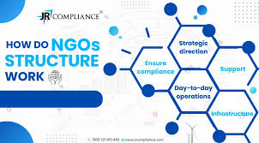initiatives for their benefit. Moreover, government has also been promoting .

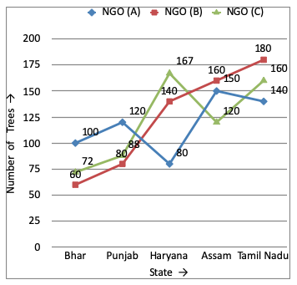

development of NGOs through financial aid and assistance programmes. NGOs with the support given by the government has been accelerating its development activities by taking up specific issues like Poverty alleviation, child rights, caste stigma and discriminations, women rights, child labor, rural development, water and sanitation, environmental issues etc., In the last two decades the role of NGOs have become proactive in the social sector development-education, health etc.,NGOs have played a crucial role in sending the school dropouts back to the school especially in rural areas thus upholding the Right to education. And also the heath sector development programmes like Leprosy eradication programme and programs on eliminating TB, malaria and improving water and sanitation

facilities by NGOs have met with huge success. The most highlighted success of NGOs could be seen in their achievement in influencing government to bring out various development-oriented policies and laws. Few of such laws and policies include: Right to Information, Integrated child development scheme(ICDS), Integrated child protection scheme(ICPS), MNREGA, Juvenile justice, Nirmal gram initiative, Rastriya swathya bhima yogna(RSBY), Various policies on women development, forest and environment development, anti-trafficking, people .

Karnataka Non Profit Organisations/ Non Governmental Organisations (NGOs/ NPOs/ VOs) are part of social development and welfare of the state people. NGOs in Karnataka has been actively working for genuine social development programmes and welfare activities of urban and rural communities. Karnataka NGOs are participating in Social development and Charitable issues organised by Government and welfare groups. Karnataka NGOs are always ready to come ahead to work for the upliftment and betterment of the children, women Development, Education, Social awareness and other objectives. Non Governmental Organisations in Karnataka are functioning for Child Education, Child Welfare, Child Rights, Women Development, Women Empowerment, Old age Homes for Old Age persons, Physically and mentally handicap persons, and Upliftment of slum Children and Women. NGOs are well organising Education, Health, Social Justice, Disaster Management, Natural Resource Management, Agriculture Development, Social Awareness, Betterment of Backward and Deprived Communities, Poverty and Distress Relief programmes. NGOs and Controversies: NGOs undoubtedly have been playing proactive role in protecting the interests of the poor and destitute and are also essential for upholding the democratic values of the country. The recent report of Intelligence bureau (IB) stated that-the working of few NGOs in the name of protests against the government activities have become detrimental to the nation development. It also mentioned that the protests of ‘foreign funding NGOs’ led to loss of 2-3% of country’s GDP. The report has brought the discussions and debates about NGOs accountability into fore. It is true that NGOs must raise voice to protect the rights of people and protest but it is also equally important for them to provide the alternatives for the government to ensure development. Mere protests and stalling development activities would.

with ‘think-tank’ way of functioning and provide alternative solutions to the government since after all the emergence of NGOs linked to the requirement of best effective alternative approaches. It is well known fact that several NGOs obtaining funds from the foreign sources for their activities. It is also true that these NGOs played crucial part in protests against setting up coal and thermal project plants and Konndankulam nuclear project which led to power shortages in the respective states. In the wake of IB report, there are few arguments from different quarters to block the option of availing foreign funds. But in a country like India where income source is low and high difficulties associated in raising funds which are primary for NGOs to fulfill their minimum requirements it is definitely not acceptable to stop the foreign funds. Instead of blocking the foreign funds it is necessary for government to ensure further transparency in categorizing the NGOs based on their funds sources. It would also prove effective if government tightens the scrutiny procedures through foreign contribution (regulation) act, 2010. And also it is necessary that NGOs to ensure transparency in their governance frame work and board functioning.

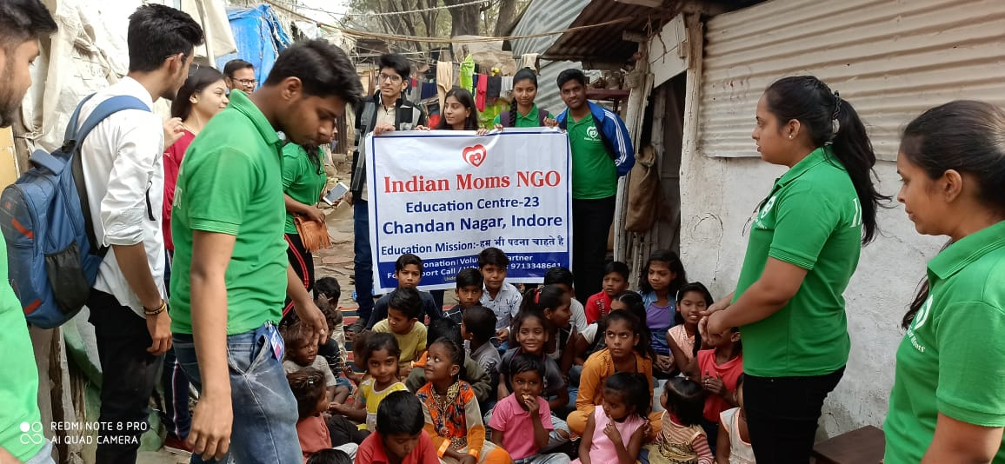

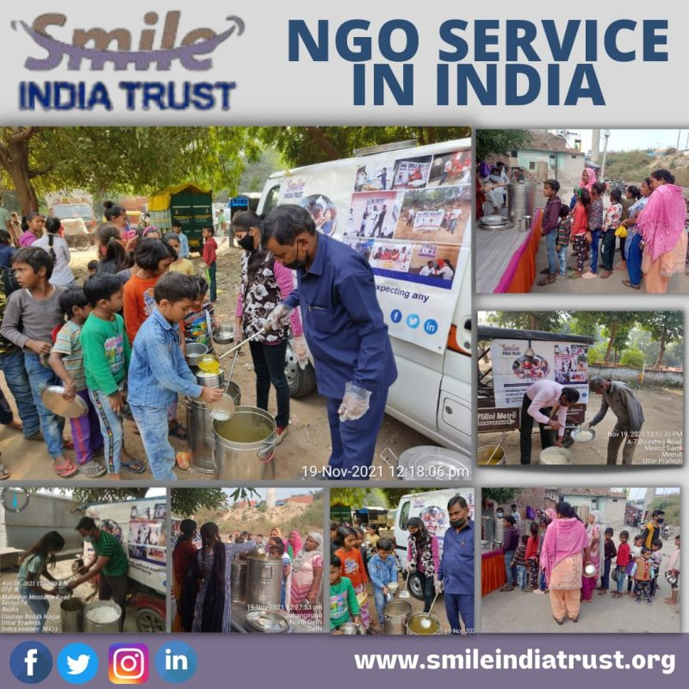

It is well known fact that several NGOs obtaining funds from the foreign sources for their activities. It is also true that these NGOs played crucial part in protests against setting up coal and thermal project plants and Konndankulam nuclear project which led to power shortages in the respective states. In the wake of IB report, there are few arguments from different quarters to block the option of availing foreign funds. But in a country like India where income source is low and high difficulties associated in raising funds which are primary for NGOs to fulfill their minimum requirements it is definitely not acceptable to stop the foreign funds. Instead of blocking the foreign funds it is necessary for government to ensure further transparency in categorizing the NGOs based on their funds sources. It would also prove effective if government tightens the scrutiny procedures through foreign contribution (regulation) act, 2010. And also it is necessary that NGOs to ensure transparency in their governance frame work and board functioning.

**Conclusion:** Non-Government organizations (NGOs) are the groups or institutions or organizations that are not reducible to the administrative grasp and work on ‘non-profit’ basis with the principles like social equality, altruism and human development as their foundations. In India at present there are nearly 25,000 NGOs spread across various parts of the country.In fine, the NGOs working with enhanced accountability, by providing alternative solutions to the development, in collaboration with the government and market which is the need of the hour would further strengthen the development process in India.

**Reference:**

1. Chaitanya Institute for Youth & Rural Development, Dharwad 2. Grace India Trust, Ranebennur 3. H.S.M. Education Society, Haveri 4. IDARY – Institute for Developement Agriculture & Rural Youths, Haveri 5. Karnataka State Devadasi Vemochana & Women Welfare Society, Haveri 6. Oasis Foundation for Human and Natural Resource Development, Haveri 7. Rakshith Network of Positive People, Haveri 8. Sri Basaveswara Grameen Abhivrudhi Sanstha, Haveri 9. TRDC – Tropical Research and Development Centre, Bangalore 10. Vinay Rural Development Society, Ranebennur 11. FacebookTwitterGoogle+Share 12. http://www.jetir.org/papers/JETIR1805348.pdf 13. www.jetir.org/papers/JETIR1805245.pdf 14. www.ijcrt.org/papers/IJCRT1813010.pdf 15. www.ijcrt.org/viewfull.php?&p_id=IJCRT1813018 16. http://www.ijcrt.org/papers/IJCRT1892499.pdf 17. http://www.ijcrt.org/papers/IJCRT1892501.pdf 18. http://www.ijirmps.org/research-paper.php?id=151 www.ijcrt.org © 2018 IJCRT | Volume 6, Issue 2 April 2018 | ISSN: 2320-2882 IJCRT189329 International Journal of Creative Research Thoughts (IJCRT) www.ijcrt.org 963 19.http://www.jetir.org/view?paper=JETIR1806116 20.http://www.jetir.org/view?paper=JETIR1806117 21.http://www.jetir.org/view?paper=JETIR1806118 22.http://www.jetir.org/view?paper=JETIR1806478 23.http://www.jetir.org/view?paper=JETIR1806479 24.http://www.jetir.org/view?paper=JETIR1702029 25.http://www.jetir.org/view?paper=JETIR1702030 26.http://www.ijcrt.org/viewfull.php?&p_id=IJCRT1813224 27.http://www.ijcrt.org/viewfull.php?&p_id=IJCRT1813225 28.http://www.ijcrt.org/viewfull.php?&p_id=IJCRT1813226 29.http://www.ijcrt.org/viewfull.php?&p_id=IJCRT1813316 30.http://www.ijcrt.org/viewfull.php?&p_id=IJCRT1813309 31.http://www.ijcrt.org/viewfull.php?&p_id=IJCRT1033028 32.http://www.ijcrt.org/viewfull.php?&p_id=IJCRT1033029 33.http://www.ijrar.org/viewfull.php?&p_id=IJRAR1903066 34.http://www.ijrar.org/viewfull.php?&p_id=IJRAR1903067